1. In the last section, we took a first step at our Dockerfile to build out this Nodejs Project & got this following error msg that is by intention.
2. 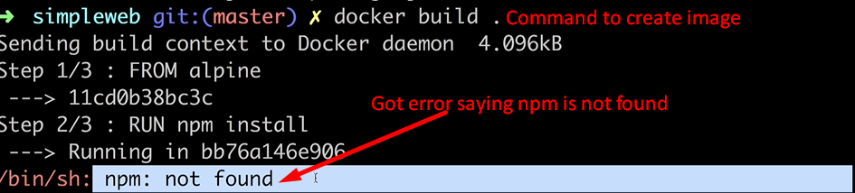
3. 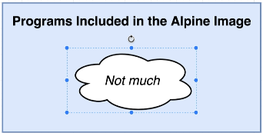
4. 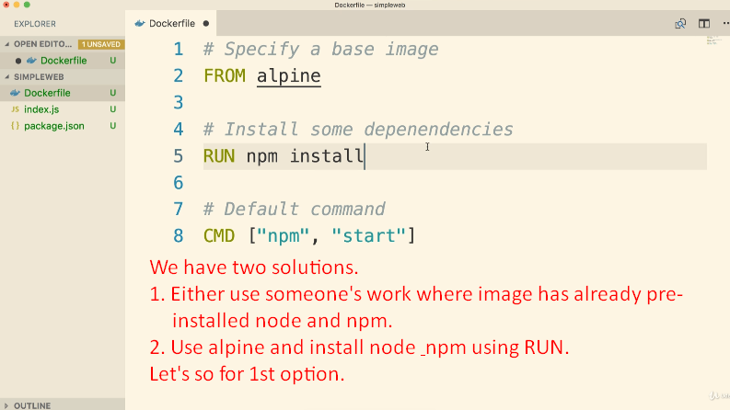
5. 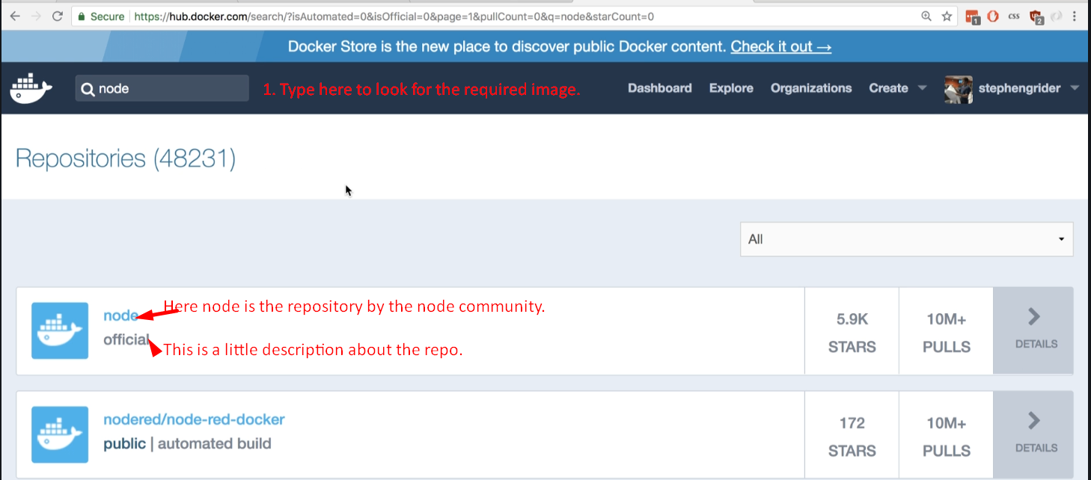
6. This repository is a Docker image that has node pre-installed on it.
7. So, we can create custom image based on this image which has node and npm pre-installed.
8. 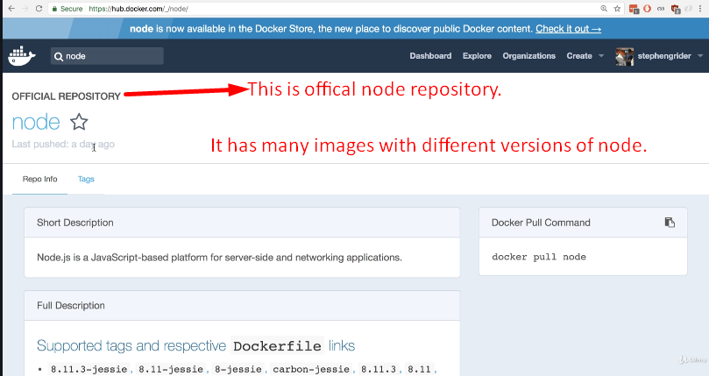
9. 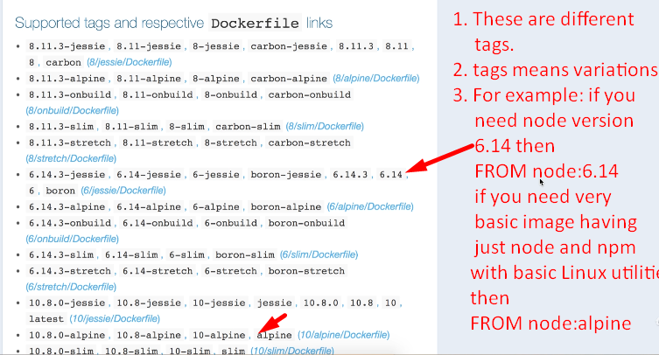
10. 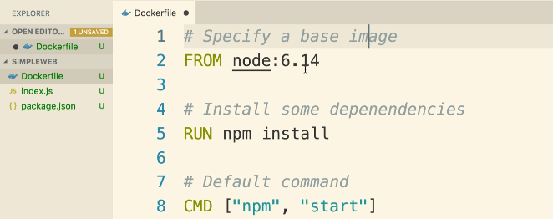
11. 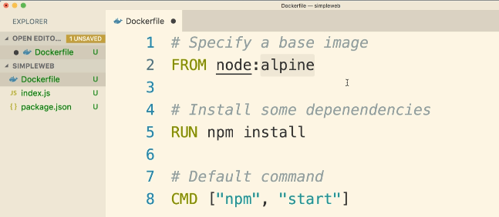  
    Above we’re using node image but very basic version of that node image as base image.   
    In the world of docker, alpine is the term used for very basic image for a particular purpose.
12. 